**Software methods and Tools – Assignment 1**

**What are four essential difficulties of software systems discussed in Fred Brooks’s paper? Explain each using your own words.**

**Ans:**

In the Fred Brook’s paper, he divided the difficulties encountered in building software systems into mainly two types. They are

1.EssentialDifficulties: The essential difficulties are innate with the software. They have partial solutions only and they cannot be detached.

2.AccidentalDifficulties: These difficulties are due to our mistakes and we make things problematic by ourselves. These are not inherent to the process.

The four essential difficulties of the software systems are

1.Complexity

2.Conformity

3.Changeability

4.Intangibility

**Complexity:**

* No two software parts are identical, they contrast with materials in the other domains.
* Large software systems have more states with more order of magnitude than computers.
* Complexity comes from strong relationship from dissimilar software artfacts such as specifications, documents, code etc.
* Problems resulting from complexity product flaws, cost overruns, lack of extensibility of system and project overview is difficult.

**Conformity:**

* Almost all the software engineers face complexity. The system must be conformed without impacted by any arbitrary changes
* If we have to integrate with a non-standard module interface, then the system had to be confirm.
* If an environment had to be changed then they will ask for the software change also. During that instance conformity comes into picture.

**Changeability:**

* In manufacturing field changes are less common, the completed products are recalled less often. The changes that need to be made are usually done in next model.
* Whereas in the change frequency is more.
* This changes are requested by the client regarding functionality but the functionality change creates change in the software. It requires a significant rework on the existing system.

**Invisibility:**

* Software is invisible by its nature and it is difficult to represent all the details in just one single diagram.
* The UML diagrams, flow charts can represent the software functionality to a maximum extent but it may lead to different understanding from different people. This lack of visualization creates problems for the engineer.

**(2) Pick one software method or tool that you used before and specifically explain whether or not you think this method or tool is a “promising attack” on the essential difficulties mentioned above.**

**Ans:**

I used coded UI testing automation tool and I faced the below problems while using the tool. The complexity related problems are:

* Some UI controls can’t be found by the UI automation framework that is currently used. This may be due to technical limitations of the UI automation framework or the accessibility support for the UI controls not executed properly in the product code. Whatever may be the reason this often prevents tests from being automated until the issues are resolved.
* Test validation is not easy, especially for UI tests or UI changes that require manual verification from testers.
* Complex test cases cannot be automated using this tool.
* Timing issues are one of the most common and annoying problems that we encounter in UI automation. The product code and the test code run in different processes, which sometimes results in their getting out of sync. It isn’t easy to handle or debug a timing issue.

Issue related to conformity:

* Every UI automation test is created and written based on the expected product behaviors. So, if a developer modifies a product behavior or UI layout, or modifies a control property, then we have to keep the system conformed by changing the automation tests according to that

Issue related to changeability:

* While the project is in initial stage in waterfall model they suddenly transformed the system to agile process which requires changes in most of the procedures we are adopting.

Invisibility issues usually exists in any software as we cannot show the entire software in some simple diagrams.

**2. (50 points) Make a class schedule for this course using Microsoft Project 2013.**

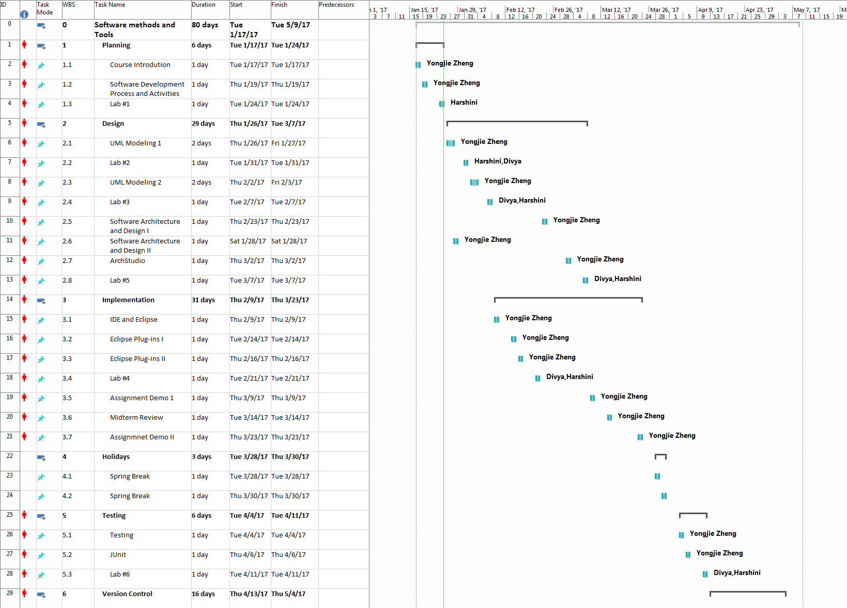

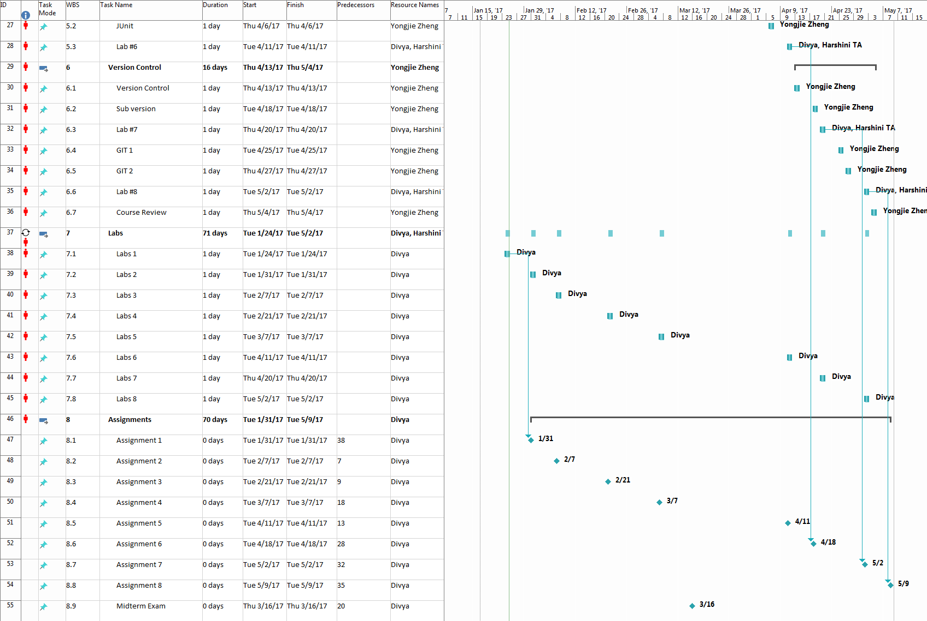

The elaborate screen shots and project file are in the below folder.

